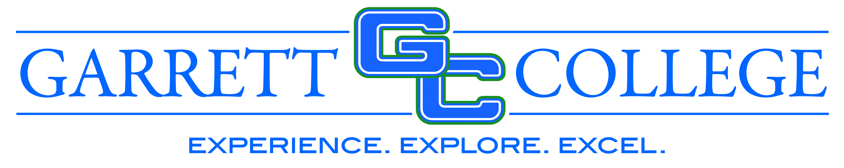

Questions & Answers
for
Orchestra Shell System RFP
July 25, 2022

Question #1 Where and how is the bid and bid bond to be sent? Is UPS/FED EX acceptable?
Answer:
“Proposals can be hand-delivered or mailed to the Garrett College Facilities Office at the following address.
Garrett College
687 Mosser Road
McHenry, MD 21541
Attn. Ms. Chris Jones”

UPS and FED EX are acceptable as long as the Proposal is received by 11:00 AM local time on July 28, 2022. Please note that “guaranteed overnight delivery” services do not always include our location in McHenry, MD. Late submissions will not be accepted.

Bonds are to be submitted as part of the Proposal, per the RFP Section “Proposal Format” item 6.

Question #2 Spec section 116123.1.6.E.2 state that contractor is responsible as well for section 116129 Pipe Grids and Fixed Lighting Pipes. Section 116129 does not appear to be included with the specifications. Please forward or clarify.
Answer: Specification 116123 – Theatrical Rigging is included for information and coordination only. Rigging is installed by other. Pipe Grids and Fixed Lighting Pipes / Spec 116129 do not pertain to this Orchestra Shell installation.
Question #3 Is this a union site or open shop?
Answer: There are no requirements with respect to union or open shop.
Question #4 Is this a prevailing wage job?
Answer: There are no requirements with respect to prevailing wages.
Question #5 Is certified payroll required?
Answer: There are no requirements with respect to certified payroll.
Question #6 What is the estimated award date?
Answer: It is the college’s intent to award the contract for the Orchestra Shell System as soon as possible after the July 28th submission date. The RFP Review Team is scheduled to review the proposals individually, then meet August 2 to finalize their recommendation for contract, with the goal to have the contract awarded by August 8th.

Question #7 What is the estimated project start date?
Answer: The Performing Arts Center construction started in 2020.
Question #8 What is the estimated project completion date?
Answer: The Performing Arts Center completion date is estimated for the end of August 2022.
Question #9 Will the College be employing an electrical contractor to furnish and install the power and control requirements of the motorized rigging systems?
Answer: The electrical contractor that is responsible for the installation of power and control for the motorized rigging, is a subcontractor of the college’s general contractor for the Performing Arts Center Project.
Question #10 Is there a bid bond and/or a P&P bond template for us to use?
Answer: The college does not specify a bond template(s). Standard AIA documents or similar will suffice.
Question #11 Is compliance with article H of the Bid Affidavit required?
Answer: The Maryland Annotated Code Section 13-221 requirement does not need to be met.
Question #12 Is compliance with article K of the Bid Affidavit required?
Answer: The affirmation of Section K. of the Bid Affidavit is not required.

